day8 morning assinment

Bhanu Prakash Reddy Chilukuri

NBHEALTHTECH

02-02-2022

|  |
| --- |
| 1. Declare and initialize a list with 8 values.  write for loop, foreach loop, lambda, LINQ query  to print even number. |

**Code:**

internal class Program

{

//Author : Bhanu Prakash Reddy Chilukuri

//Purpose : Declare and intialize a list with a 8 values. write for for loop, foreach,lambda,LINQ query `

static void Main(string[] args)

{

List<int> data = new List<int>() { 18, 25, 85, 44, 64, 28, 108, 55 };

//Even numbers using for loop

for(int i=0;i<data.Count;i++)

{

if(data[i]%2==0)

Console.WriteLine(data[i]);

}

//using foreachloop

foreach (var d in data)

{

if (d % 2 == 0)

Console.WriteLine(d);

}

//lamda expression

data.Where(d=>d%2==0).ToList().ForEach(d=>Console.WriteLine(d));

//LINQ Query

var result=from d in data

where d%2==0

select d;

result.ToList().ForEach(d => Console.WriteLine(d));

Console.ReadLine();

}

}

**Output:**

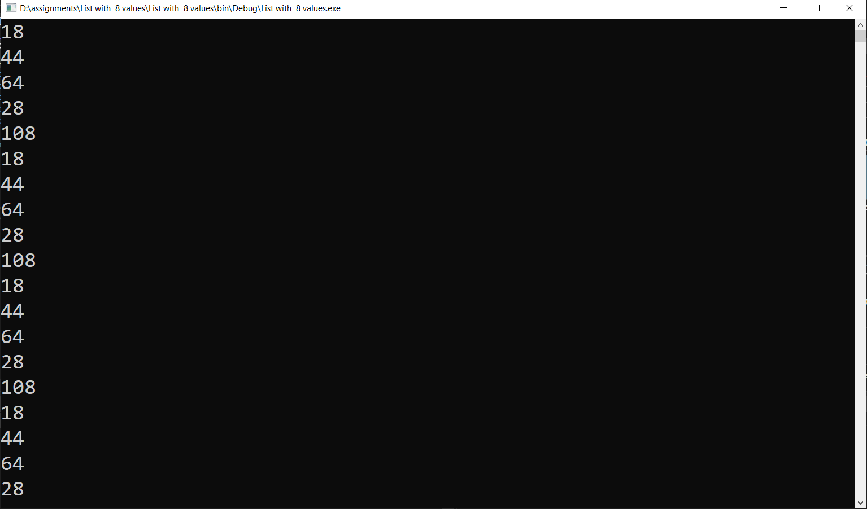

|  |
| --- |
| 2.Create a class Employee with three variables as discussed in the class and create a list of Employees  public int id;  public string name;  public int salary;  write  for loop  foreach loop  lambda expression  linq query |

**Code:**

//Author: Bhanu Prakash Reddy

//Create a Class Employee with three variables with foor, foreach, lambda, linq query

{

internal class Employee

{

public int id;

public string name;

public int salary;

}

}

internal class Program

{

static void Main(string[] args)

{

List<Employee> employees = new List<Employee>()

{

new Employee(){id=11,name="Bhanu",salary=6000},

new Employee(){id=12,name="krishna",salary=7000},

new Employee(){id=13,name="Raja",salary=4000},

new Employee(){id =14,name="Fareed",salary =4500}

};

//For loop

for (int i = 0; i < employees.Count; i++)

{

Console.WriteLine($"Employee Id: {employees[i].id},Employee Name: {employees[i].name},Employee Salary: {employees[i].salary}");

}

//For Each Loop

foreach(var e in employees)

{

Console.WriteLine($"Employee Id: {e.id},Employee Nmae: {e.name},Employee Salary: {e.salary}");

}

//Lambda Expression

employees.ForEach(e => Console.WriteLine($"Employee Id: {e.id},Employee Nmae: {e.name},Employee Salary: {e.salary}"));

//Linq query

var result = from e in employees

select e;

result.ToList().ForEach(e => Console.WriteLine($"Employee Id: {e.id},Employee Nmae: {e.name},Employee Salary: {e.salary}"));

Console.ReadLine();

}

}

**Output:**

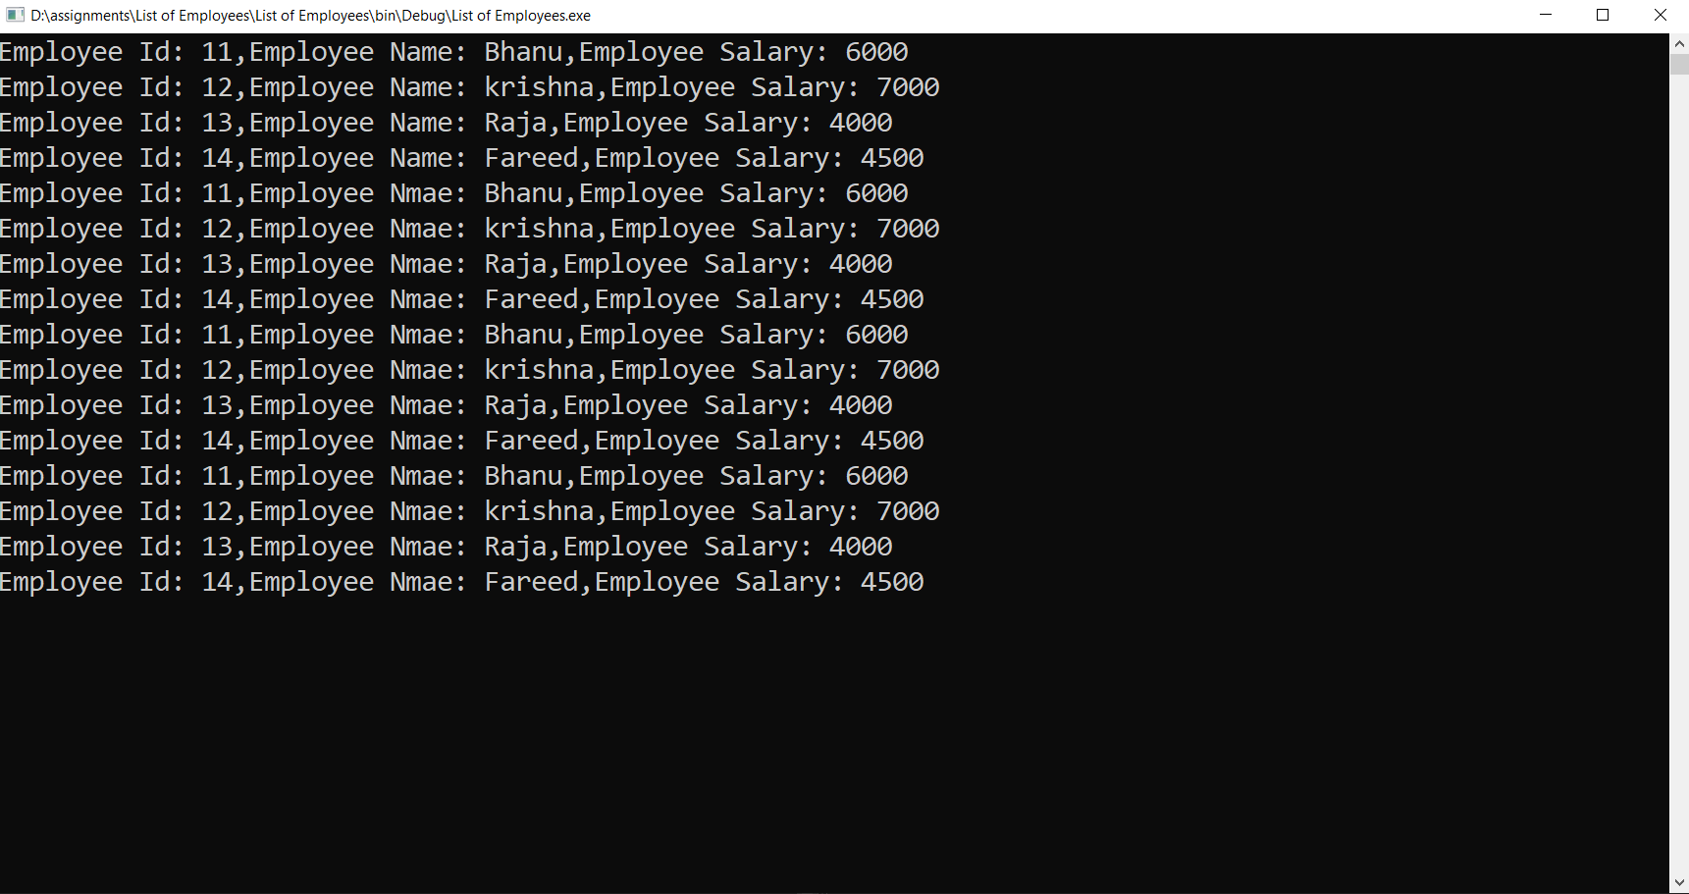

|  |
| --- |
| 3. Create a class Product and add variables id, name, price, brand and print product (name and brand) whose price is more than 500 using  for  foreach loop  lambda  linq query |

**Code:**

//Author: Bhanu Prakash reddy

//create a class product and print name and brand whose price is more than 500

internal class Product

{

public int id;

public string name;

public int price;

public string brand;

}

internal class Program

{

static void Main(string[] args)

{

List<Product> products = new List<Product>()

{

new Product(){id=11,name="Beast",price=1500,brand="Kookaburra"},

new Product(){id=12,name="Kahuna",price=450,brand="kookaburra"},

new Product(){id=13,name="Nexus",price=1250,brand="SG"},

new Product(){id =14,name="Super Cover",price=300,brand ="SG"},

new Product(){id =15,name="Vapor",price=2500,brand ="Grey Nicollas"}

};

//For loop

for (int i = 0; i < products.Count; i++)

{

if(products[i].price>500)

Console.WriteLine($"Product Name: {products[i].name},Product Brand: {products[i].brand}");

}

//For Each Loop

foreach (var p in products)

{

if(p.price>500)

Console.WriteLine($"Product Name: {p.name},Product Brand: {p.brand}");

}

//Lambda Expression

products.Where(p => p.price > 500).ToList().ForEach(p => Console.WriteLine($"Product Name: {p.name},Product Brand: {p.brand}"));

//Linq query

var result = from p in products

where p.price > 500

select p;

result.ToList().ForEach(p => Console.WriteLine($"Product Name: {p.name},Product Brand: {p.brand}"));

Console.ReadLine();

}

}

**Output:**

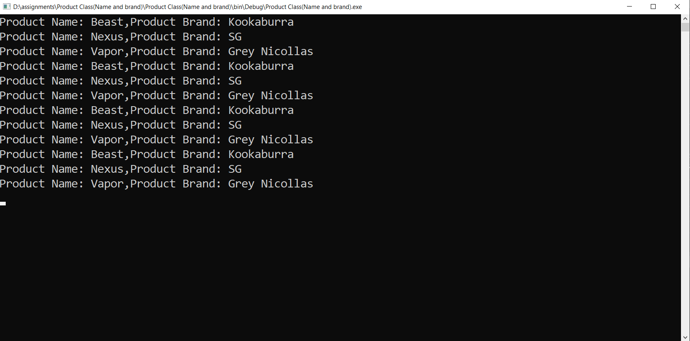

|  |
| --- |
| 4. Create a Department class and add variables id, name, empcount. write code to print id,name of departments whose empcount is greater than 50 using  for  foreach  lambda  linq query |

**Code:**

//Author: Bhanu Prakash Reddy

//Create a department class and print id and name whose empcount is more than 50

internal class Department

{

public int id;

public string name;

public int empcount;

}

internal class Program

{

static void Main(string[] args)

{

List<Department> departments = new List<Department>()

{

new Department(){id=11,name="HR Deapartment",empcount=45},

new Department(){id=12,name="Developer Department",empcount=94},

new Department(){id=13,name="QA Department",empcount=75},

new Department(){id =14,name="BA Department",empcount=42},

new Department(){id =15,name="Production Department",empcount=51}

};

//For loop

for (int i = 0; i < departments.Count; i++)

{

if (departments[i].empcount > 50)

Console.WriteLine($"Department Id: {departments[i].id},Department Name: {departments[i].name}");

}

//For Each Loop

foreach (var d in departments)

{

if (d.empcount > 50)

Console.WriteLine($"Department Id: {d.id},Department Name: {d.name}");

}

//Lambda Expression

departments.Where(d => d.empcount > 50).ToList().ForEach(d => Console.WriteLine($"Department Id: {d.id},Department Name: {d.name}"));

//Linq query

var result = from d in departments

where d.empcount > 50

select d;

result.ToList().ForEach(d => Console.WriteLine($"Department Id: {d.id},Department Name: {d.name}"));

Console.ReadLine();

}

}

**Output:**

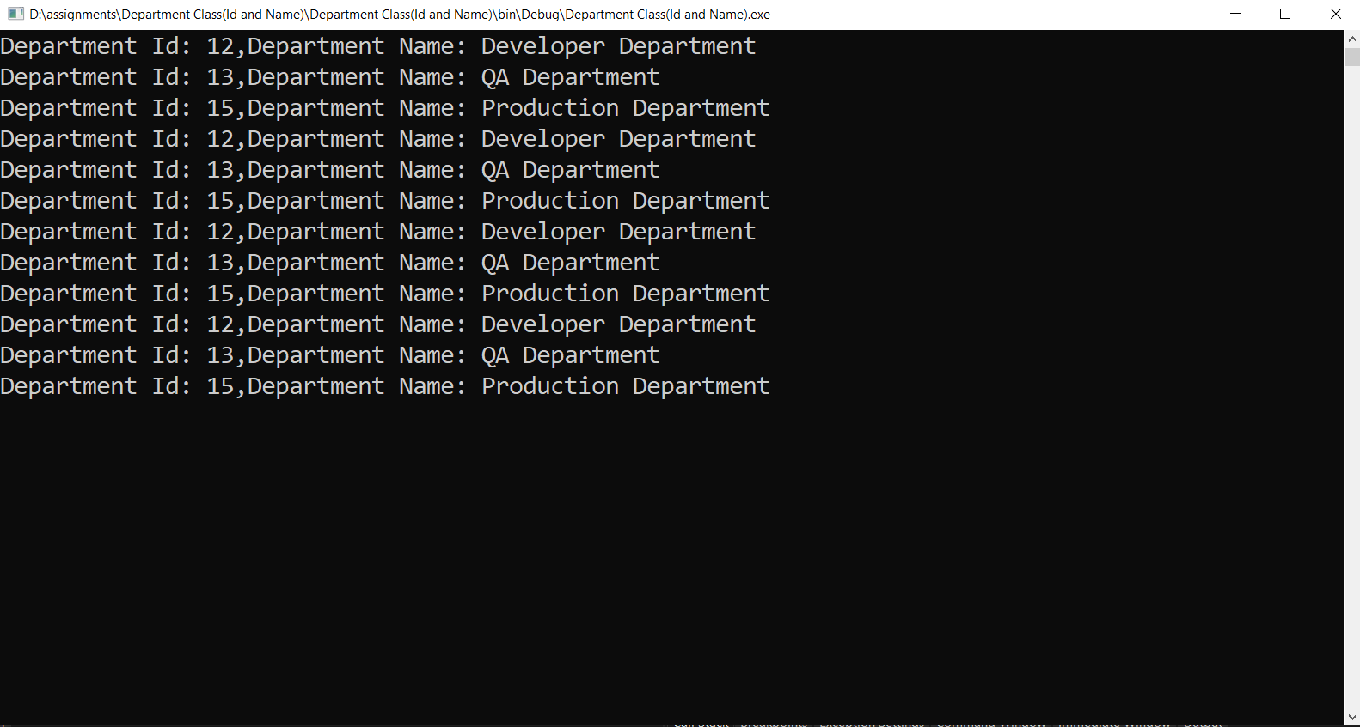

|  |
| --- |
| 5. Create your own class and variables and initialize with some values using  For, foreach, lambda and linq query |

Code:

internal class Program

{

static void Main(string[] args)

{

List<NBA_Players> players = new List<NBA_Players>()

{

new NBA_Players(){name="Lebron",games=1346,championships=4,careerpoints=36414},

new NBA_Players(){name="Kobe",games=1346,championships=5,careerpoints=33643},

new NBA_Players(){name="KD",games=920,championships=2,careerpoints=24936},

new NBA_Players(){name="Iverson",games=914,championships=0,careerpoints=24368},

new NBA_Players(){name="Shaq",games=1207,championships=4,careerpoints=28596}

};

//For loop

for (int i = 0; i < players.Count; i++)

{

if (players[i].careerpoints > 25000)

Console.WriteLine($"Player Name: {players[i].name}, Player Championships: {players[i].championships}");

}

//For Each Loop

foreach (var p in players)

{

if (p.careerpoints > 25000)

Console.WriteLine($"Player Name: {p.name}, Player championships: {p.championships}");

}

//Lambda Expression

players.Where(p => p.careerpoints > 25000).ToList().ForEach(p => Console.WriteLine($"Player Name : {p.name}, Player Championships: {p.championships}"));

//Linq query

var result = from p in players

where p.careerpoints > 25000

select p;

result.ToList().ForEach(p => Console.WriteLine($"Player Name: {p.name}, Player Championships: {p.championships}"));

Console.ReadLine();

}

}

Output:

